**DESIGN AND ANALYSIS OF ALGORITHMS**

**LAB 01: Asymptotic notation of complexity**

# Complexity notation

$T(n)$, $f(n)$– nonnegative, monotonically increasing functions, $n$ is the input size of algorithms.

## Big-Theta Notation:

### **Definition: $T\left(n\right)∈Θ\left(f\left(n\right)\right)⇔∃c_{1}>0, ∃c_{2}>0, ∃n_{0}≥0:$**

$$c_{1}*f(n)≤T\left(n\right)≤c_{2}.f\left(n\right), ∀n≥n_{0}$$

### **Example**

### if $T\left(n\right)=32n^{2}+17n+32$

$$f(n)=n^{2}$$

, i.e.

$$T\left(n\right)∈Θ\left(f\left(n\right)\right)$$

### **Big-Theta is a tight bound on the computational complexity function of algorithms**.

### **Application: After we get the complexity function, we drop all insignificant terms in the function and the coefficients to get the efficiency class of the complexity function. $T\left(n\right)=32n^{2}+17n+32$ $∈Θ\left(n^{2}\right)$**

# Sample exercises with solutions on complexity notations

Question: sort the following functions in ascending order of the growth

$$f_{1}\left(n\right)={10}^{n}$$

$$f_{2}\left(n\right)=n^{1/3}$$

$$f_{3}\left(n\right)=n^{n}$$

$$f_{4}\left(n\right)=\log_{2}{n}$$

$$f_{5}\left(n\right)=2^{\sqrt{\log_{2}{n}}}$$

**Solution:**

To compare the growth rates of these functions, let's take the limit of their ratios as n approaches infinity:

Let's analyze each pair:

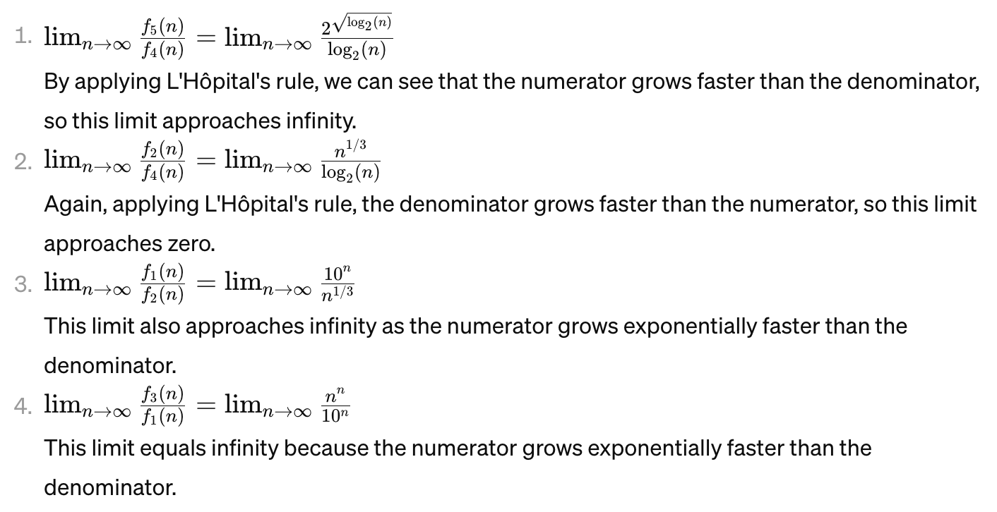

So, the functions in ascending order of growth are:

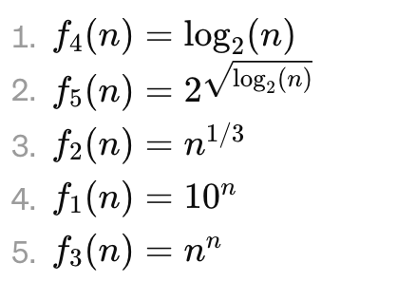

# Exercises

## Identify the efficiency class (big-Theta) of the following algorithms [in the worst cases]

### def function($A$)

# input: A – an array of $n$ numbers

1. for to do

2. for to do

3. if return false

4. return true

### def f(A):

1. # input A is an array of n number
2. n = len(A)
3. for i in range(0, n-1):
4. max = A[i]
5. imax = i
6. for j in range(i+1, n):
7. if A[j] > max:
8. max = A[j]
9. imax = j
10. A[i], A[imax] = A[imax], A[i]

### Function F(n):

#Input: $n=3^{k},$ k integer, positive

#Output: count

1. count ← 0; i = n
2. while (i ≥ 1)
   1. for j ← 1 to n do
      1. count ← count + 1
      2. print(j)
   2. end for
   3. i ← i/3

end while

### ALGORITHMS F()

1. for to of the

2. for to of the

3. if return false

4. return true

### Function f(k):

1. int i, even;
2. i := 1;
3. even := 0;
4. while( i < k ) {
5. even := even + 2;
6. i := i + 1;
7. }
8. return even .

### Algorithm: f(natural number k)

1. int i, power;
2. i := 0;
3. power := 1;
4. while( i < k ) {
5. power := power * 2;
6. i := i + 1;
7. }
8. return power .

### Algorithm bubbleSort(A : list of sortable items)

1 . n := length(A)

2 . repeat

3 . swapped := false

4 . for i := 1 to n-1 inclusive do

5 . /* if this pair is out of order */

6 . if A[i-1] > A[i] then

7 . swap(A[i-1], A[i])

8 . swapped := true

9. end if

10. end for

11. until not swapped

12.end procedure

### ALGORITHMS func()

1. for to do

2. for to do

3. if return false

4. return true

### function insertionSort(array A)

01. i ← 1

02. while i < length(A)

03. x ← A[i]

04. j ← i - 1

05. while j >= 0 and A[j] > x

06. A[j+1] ← A[j]

07. j ← j - 1

08. end while

09. A[j+1] ← x

10. i ← i + 1

11.end while

## Are the following statements true or false?

* 1. ?
  2. ?
  3. If and then $f(n)=g(n)$

(Hint: the statement is false; you may prove it with a counterexample)

## Are the following statements true or false, given two functions $f\left(n\right), g\left(n\right):f(n)∈O(g(n))$?

$\log_{2}{f(n)}∈O(\log_{2}{g(n)})$

$2^{f\left(n\right)}∈O\left(2^{g\left(n\right)}\right)$

${f(n)}^{2}∈O({g(n)}^{2})$

## Arrange the following functions in ascending order of growth:

$$f_{1}\left(n\right)=n^{2.5}$$

$$f_{2}\left(n\right)=\sqrt{2n}$$

$$f_{3}\left(n\right)=n+10$$

$$f_{4}\left(n\right)={10}^{n}$$

$f_{5}\left(n\right)={100}^{n}$ $$f_{6}\left(n\right)=n^{2}\log{n}$$

## Arrange the following functions in ascending order of growth:

$$g\left(n\right)=2^{\sqrt{\log{n}}}$$

$$g_{2}\left(n\right)=2^{n}$$

$$g_{3}\left(n\right)=n^{4/3}$$

$$g_{4}\left(n\right)=n{(\log{n})}^{3}$$

$g_{5}\left(n\right)=n^{\log{n}}$ $$g_{6}\left(n\right)=2^{2^{n}}$$

$$g_{7}\left(n\right)=2^{n^{2}}$$